**Screenshots**

**Process, initial and fixed reports**

**Code all user requirements given – Checkstyle warning**

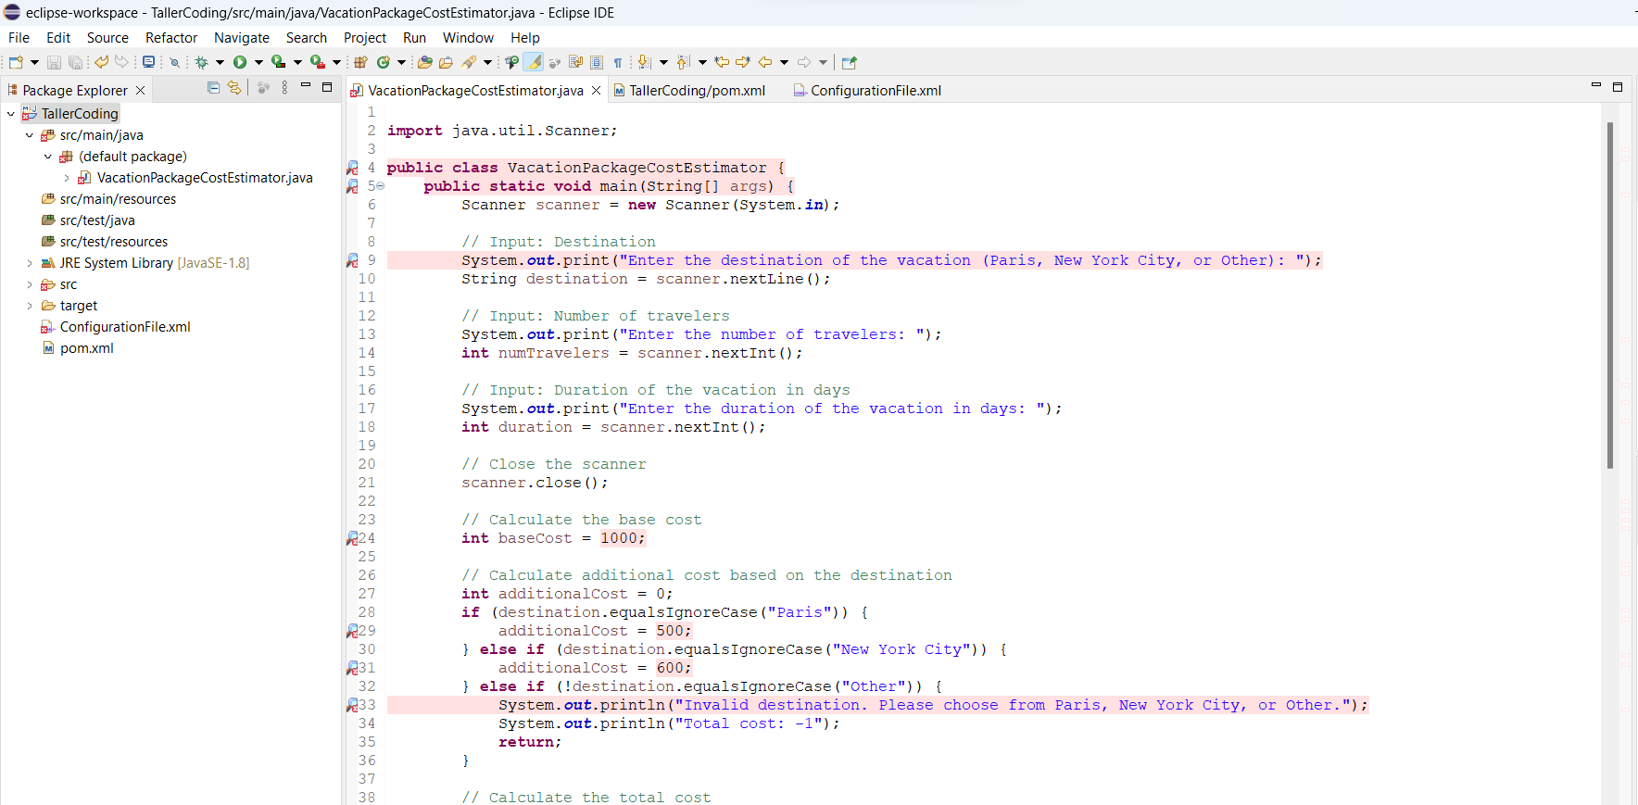

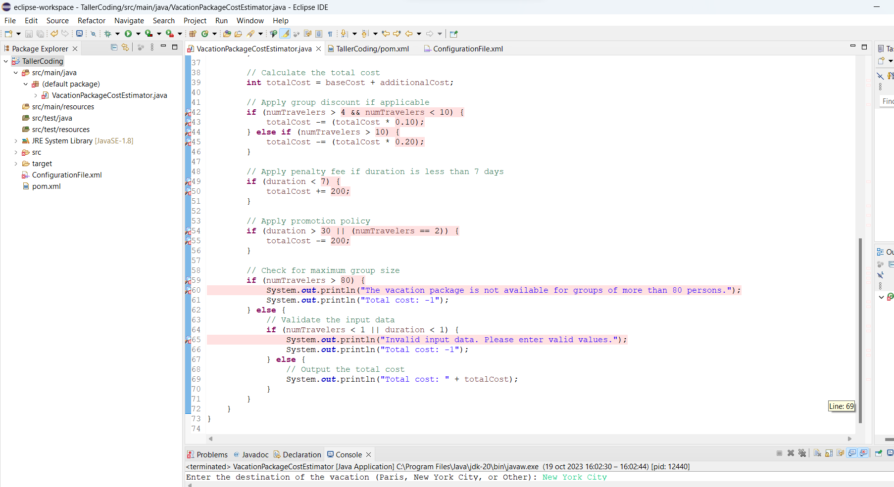

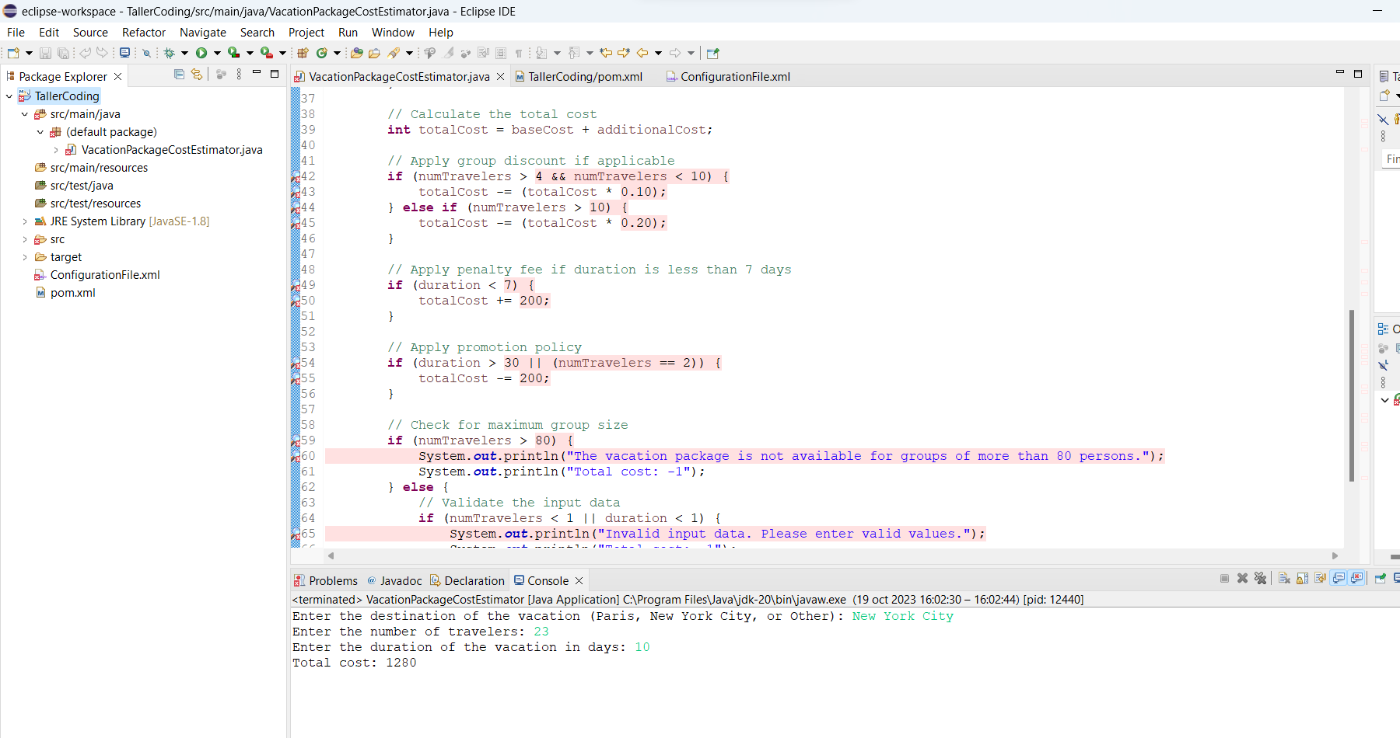

Luego de aplicar el checkstyle FreddyChecks

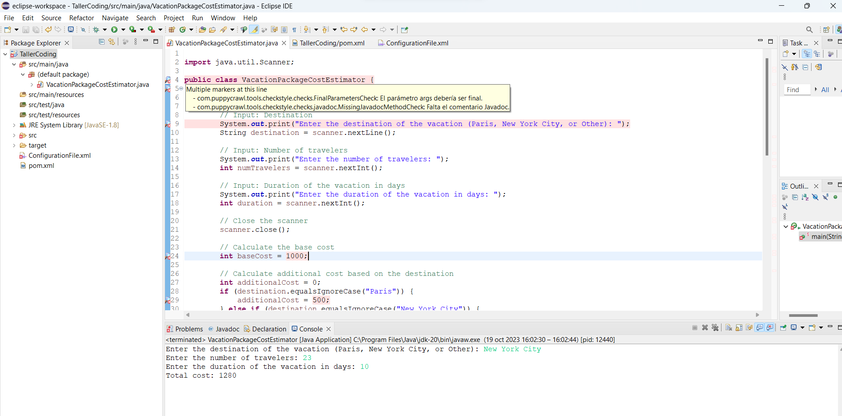

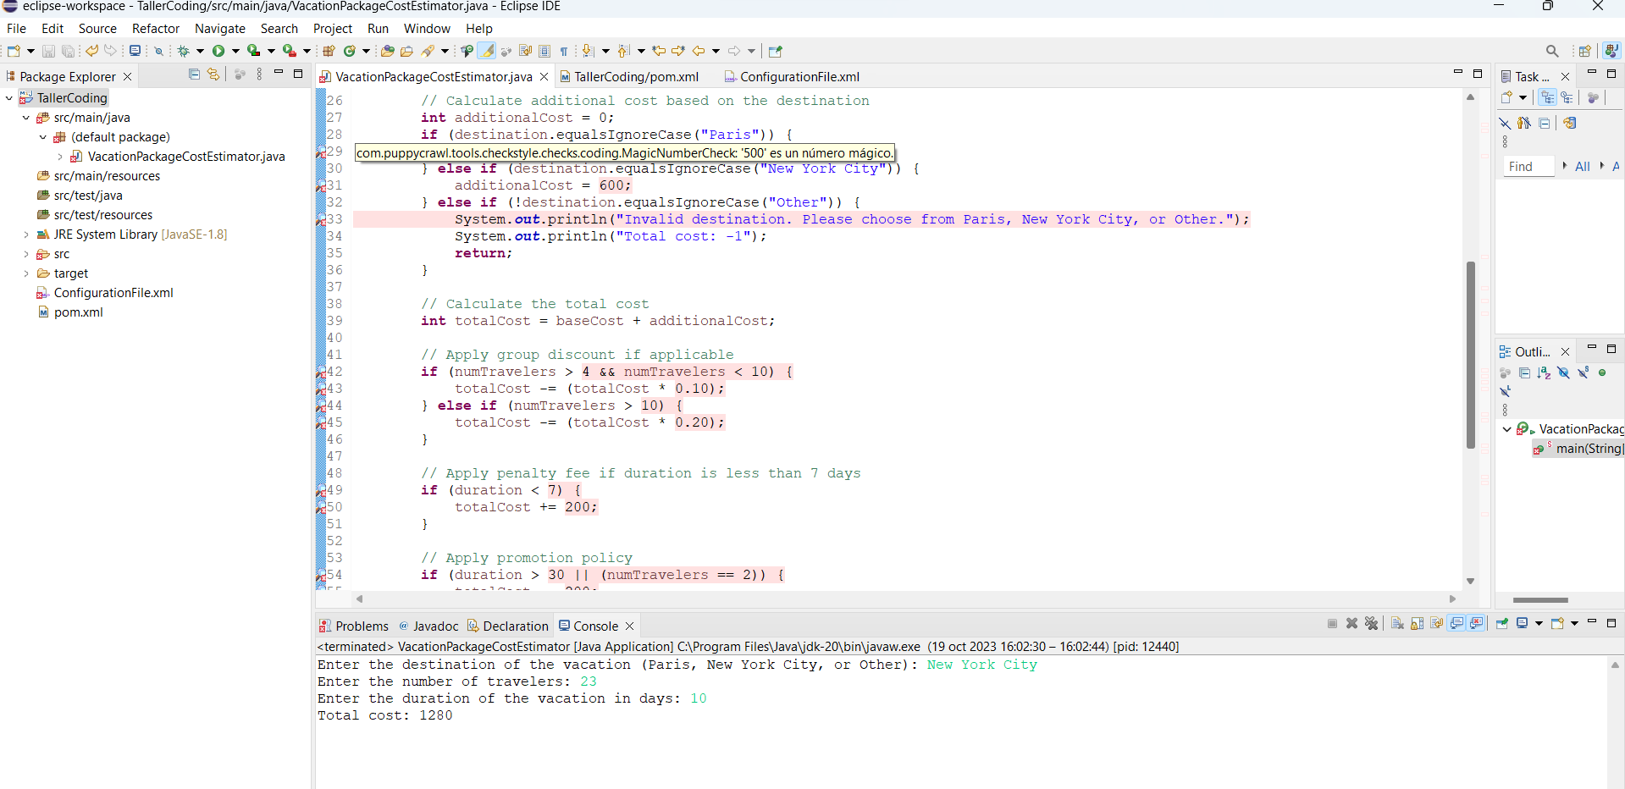

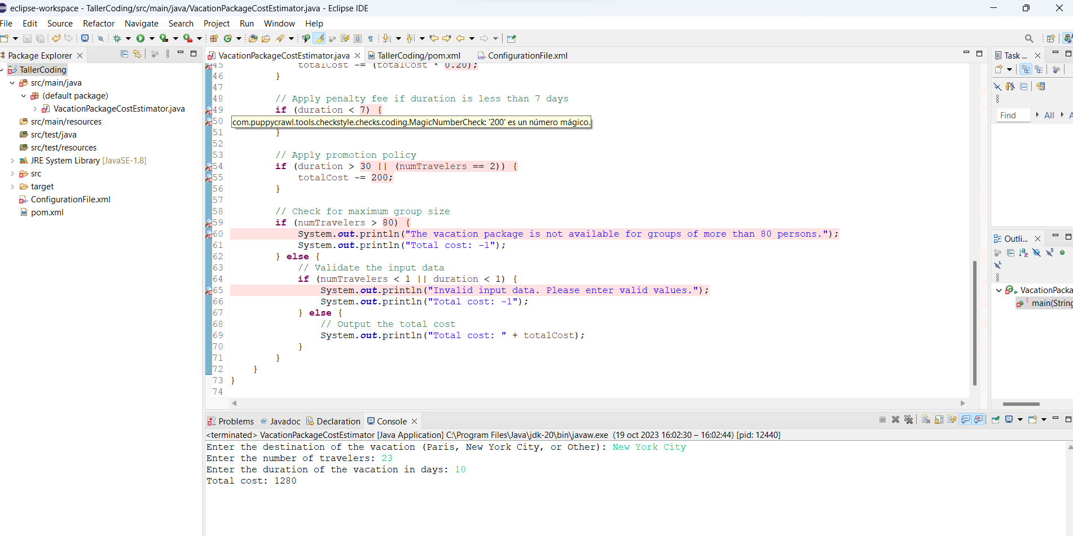

**Configure Checkstyle:**

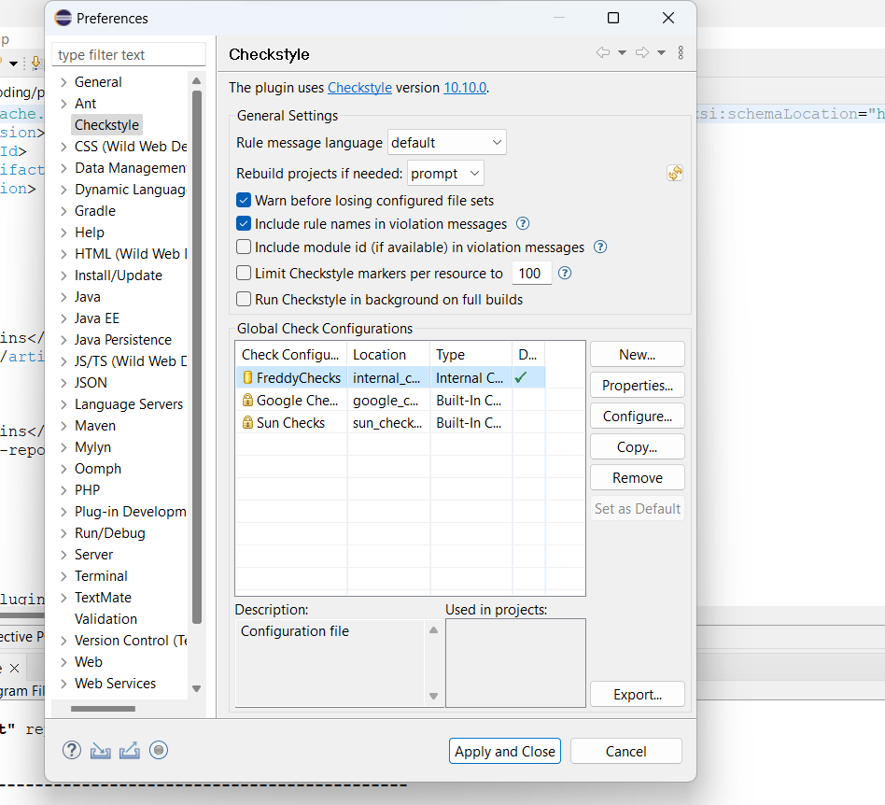

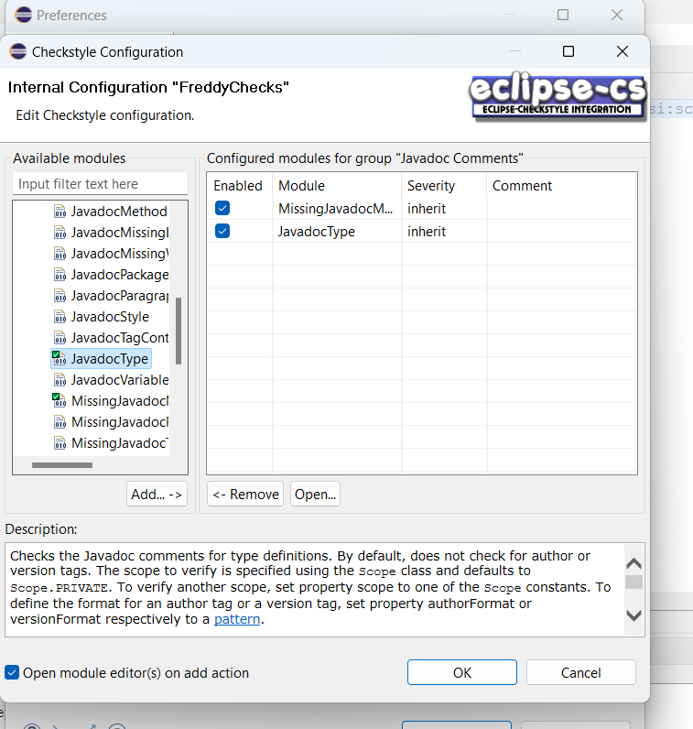

**Checkstyle with Maven**

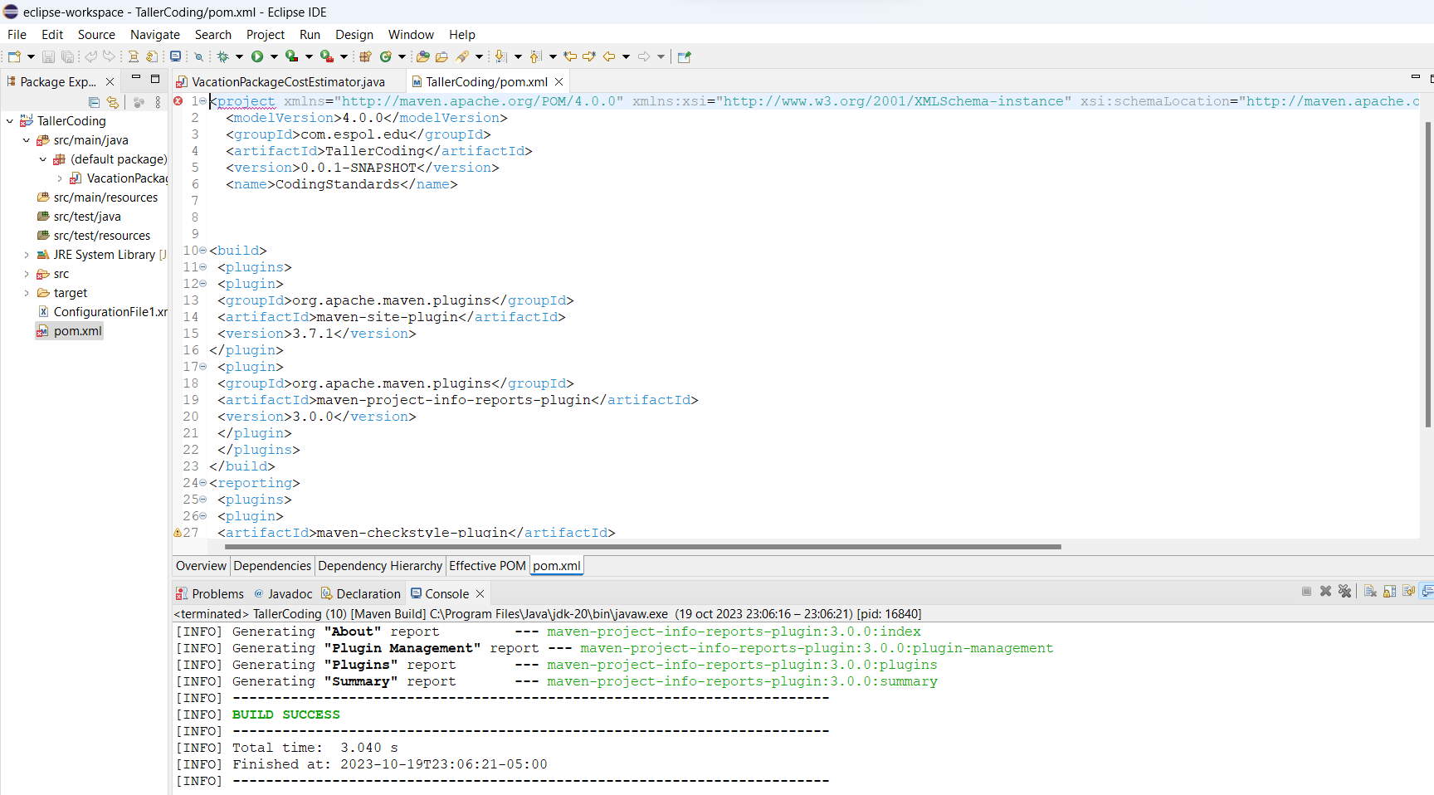

**Wait for the process to finish**

**Project Reports → Checkstyle**

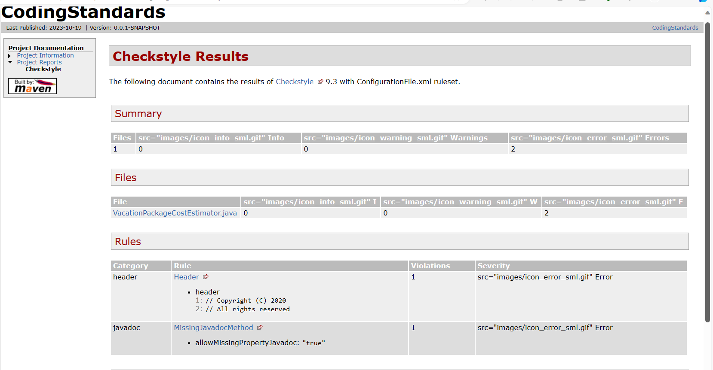

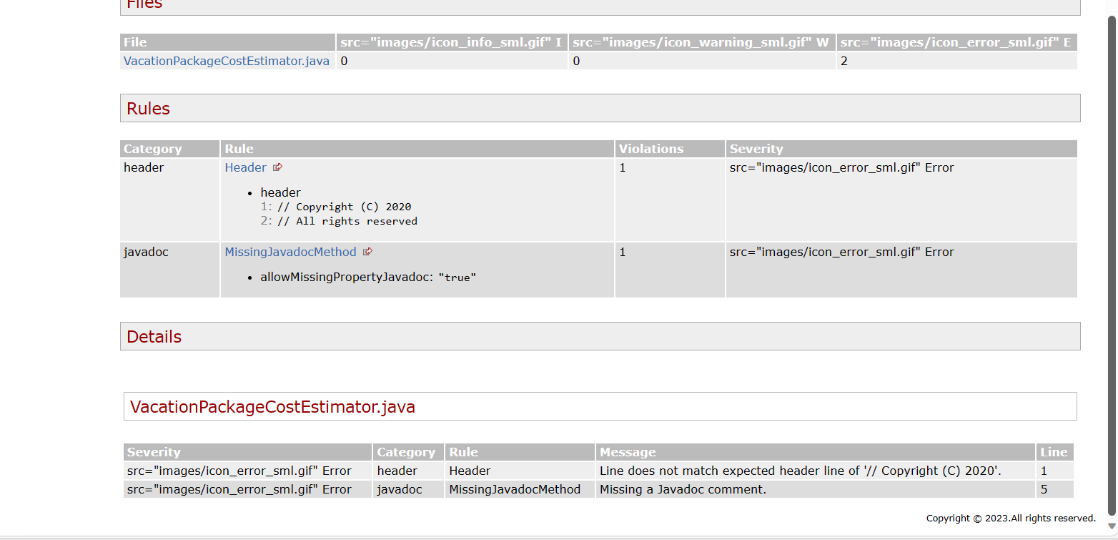

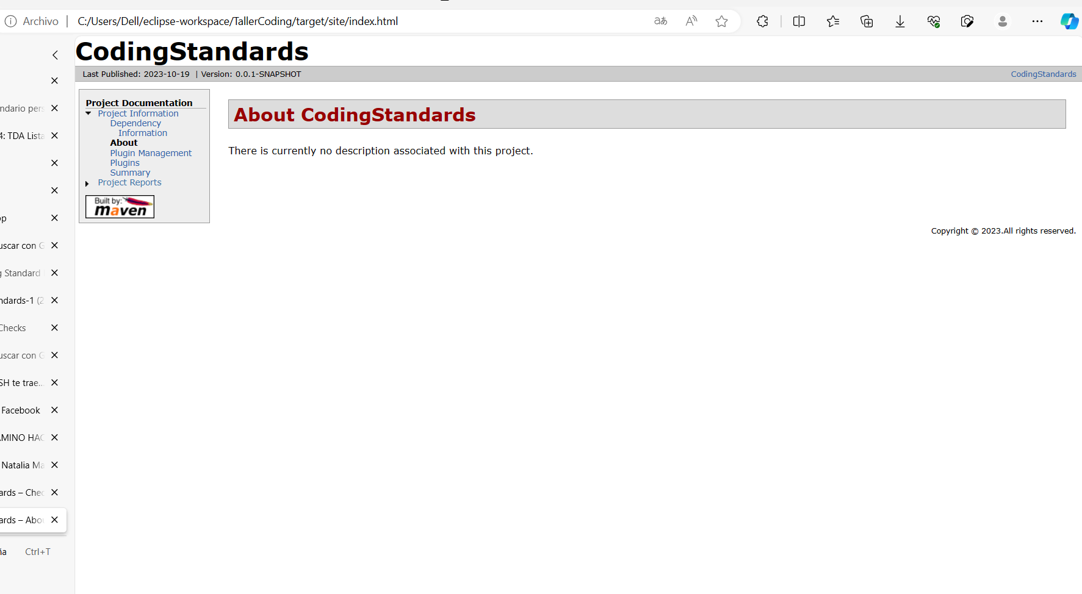

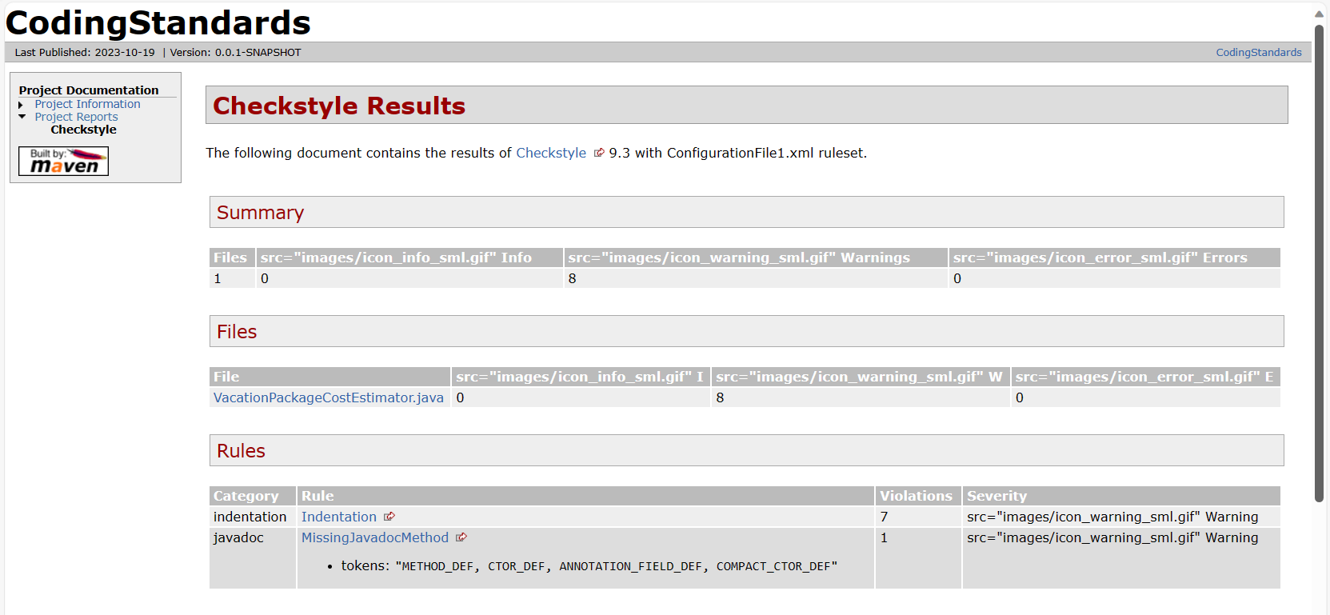

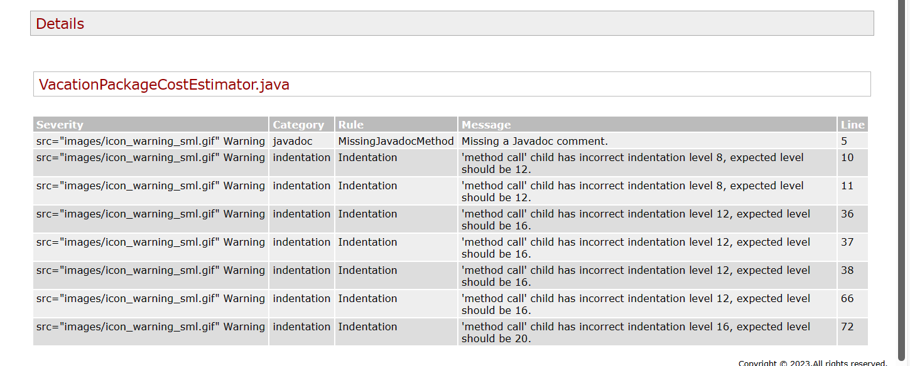

**ConfigurationFile.xml**

Add 6 more modules or properties to your XML configuration file, which may include:

a. Javadoc Method.

b. Method Name, configure a property to match names that begin with a lower-case

letter, followed by letters, digits, and underscores.

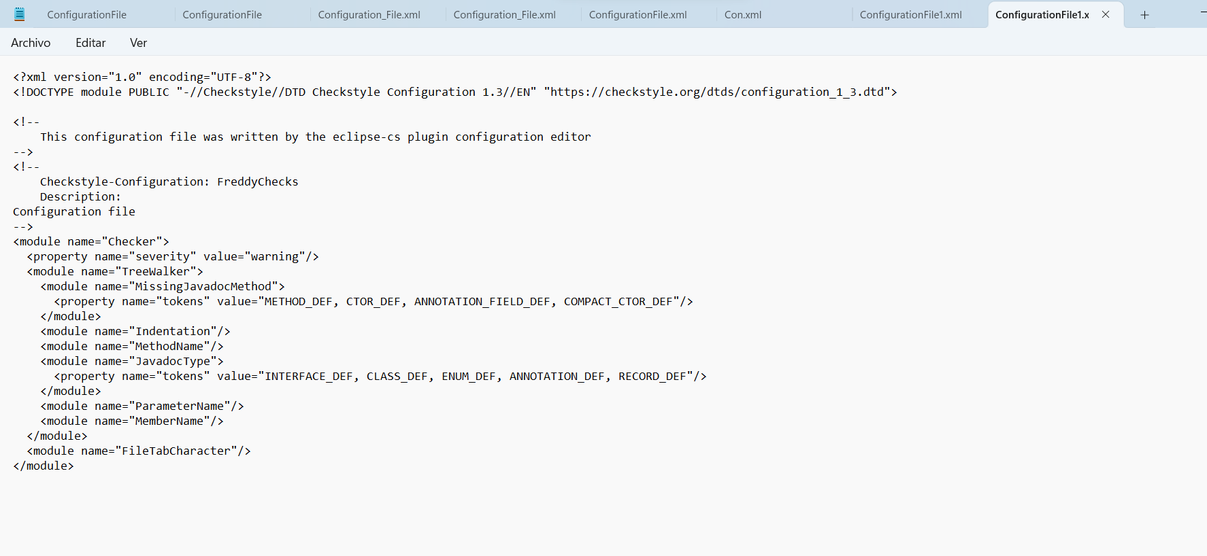

2) Generate a report.







3) Correct any errors/warnings in the code that have been generated in the report.

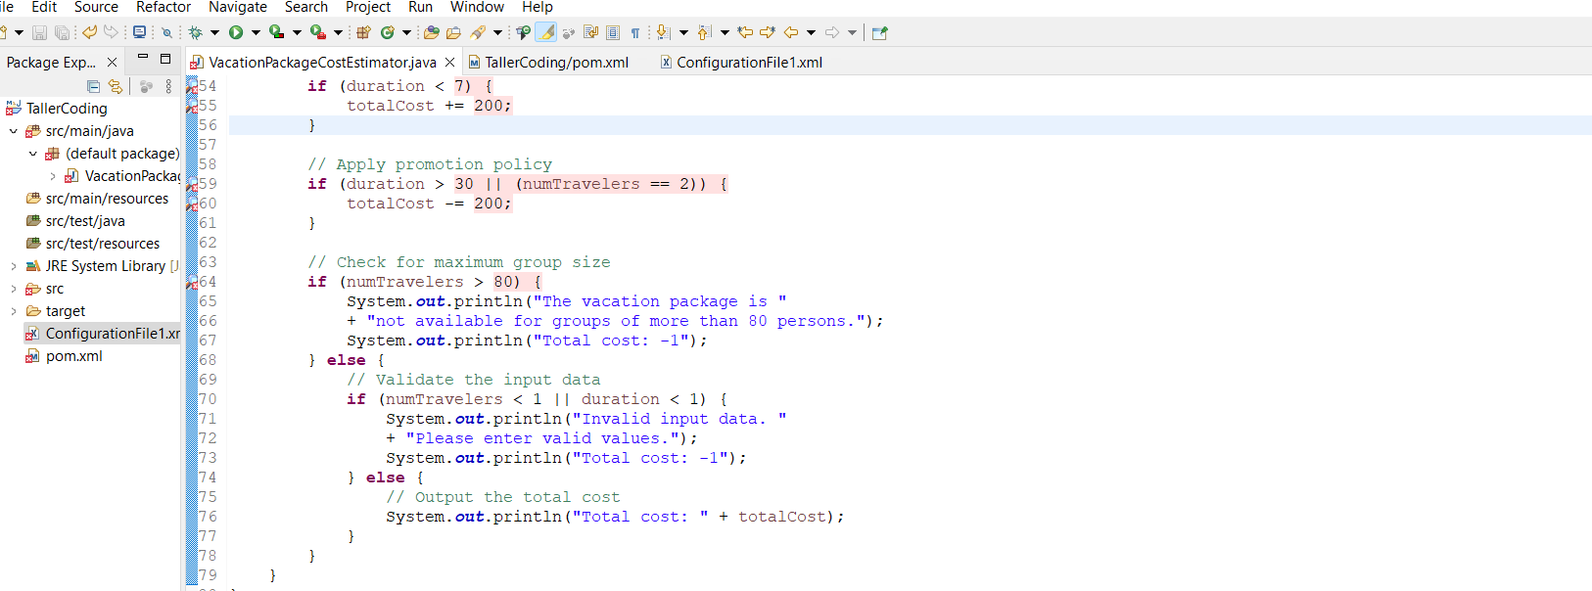

**Challenge**

**Code Project:  
  
  
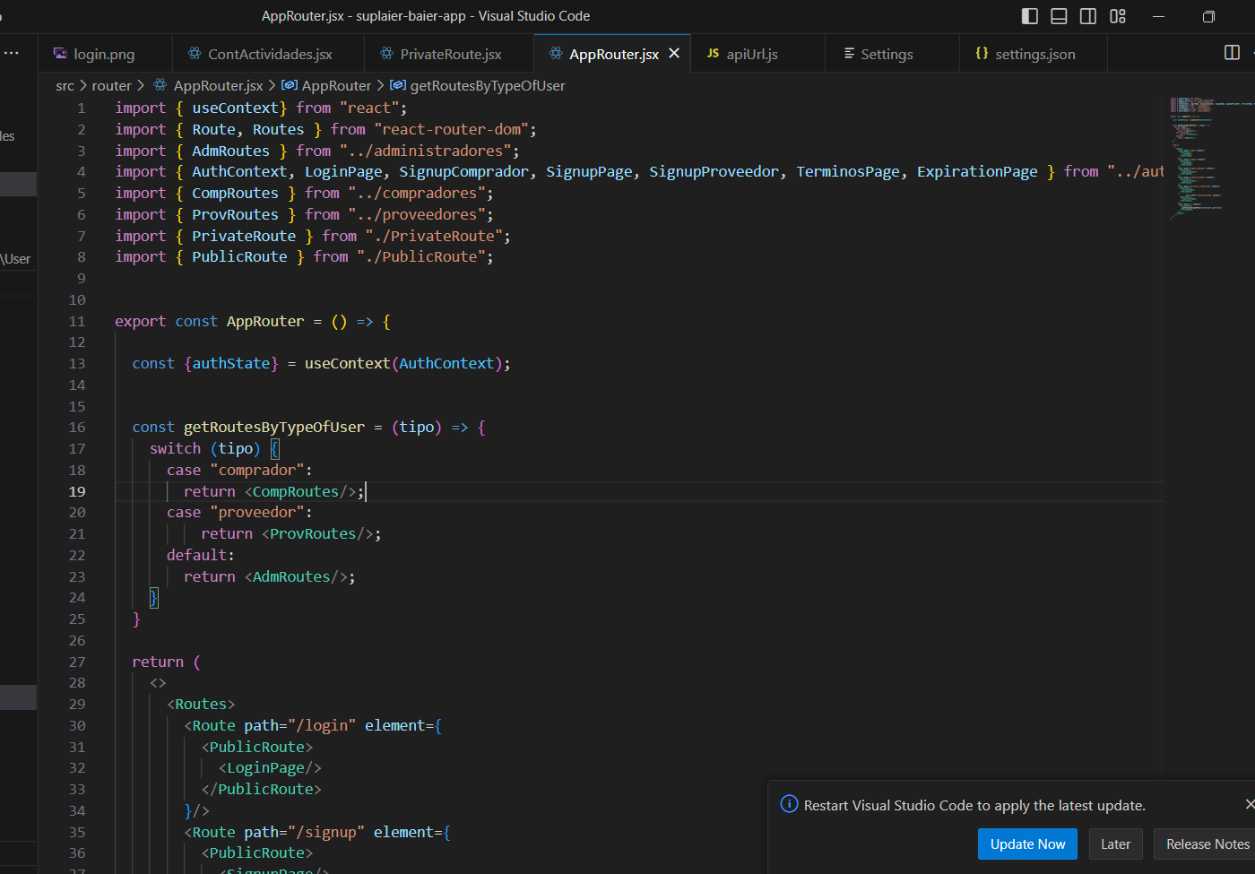**

**EsLint**

